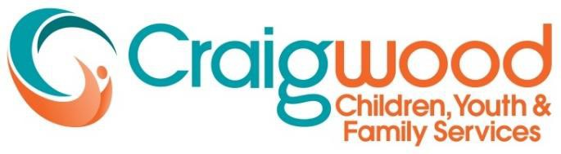

Craigwood is seeking new Board Members with a Chartered Professional Accountant designation and/or legal training to help shape, lead and meet our goals in service to the mental health needs of children, youth and families in the London /Middlesex region.
Craigwood is a fully accredited and licensed not-for-profit children's mental health centre providing a full spectrum of innovative treatment and counselling programs and a secure Youth Justice facility.
Craigwood is governed by a volunteer Board of Directors providing a broad range of expertise and perspectives on behalf of the communities we serve. The Board functions under a policy governance model with primary responsibility to provide direction to the Executive Director, who is charged with achieving the mission and goals of the agency.

Board Member Responsibilities
Through the Executive Director, the purpose of the Craigwood Board is to ensure that we:
- Have a Strategic Plan in place to carry out our mission
- Achieve measurable results
- Operate within legislation, regulation and approved financial guidelines
- Are responsive to the needs and aspirations of the community
- Act ethically in all our activities

Board Members Qualifications
- Candidates for Board membership are vetted initially through interviews with the Board’s leadership team and with the Executive Director, as well as a police background check. The candidate may then be elected to a 4- year term by a simple majority of the full board membership. In recruiting and selecting candidates to fill a vacancy, the Board seeks those who live in our service area and provide a balance in experience and diversity. We are specifically asking for applications from those with a Chartered Professional Accountant designation and lawyers with applicable experience. Other beneficial areas may include:
- Legal matters including contract law and liability
- Finances and budget management
- The regional education system and its services
- Health services and community partners
- Business management and entrepreneurship
- Public relations, marketing and fundraising
- Parents, youth and clients who have lived experience in children’s mental health services.
- Fluency in French language and representative of the diversity in our community, including indigenous communities
- The interests and needs of the Ailsa Craig/Nairn community Interested candidates are invited to submit their application in confidence to:
Board Recruitment Committee general@craigwood.on.ca

